The Drone Front
U.S. Drone Attacks from September, 3rd thru October, 27th 2010-11-22

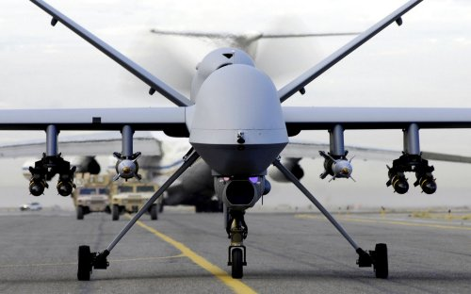

Roy Keyes

The Drone Front Pakistan’s Federally Administered Tribal Area (FATA).
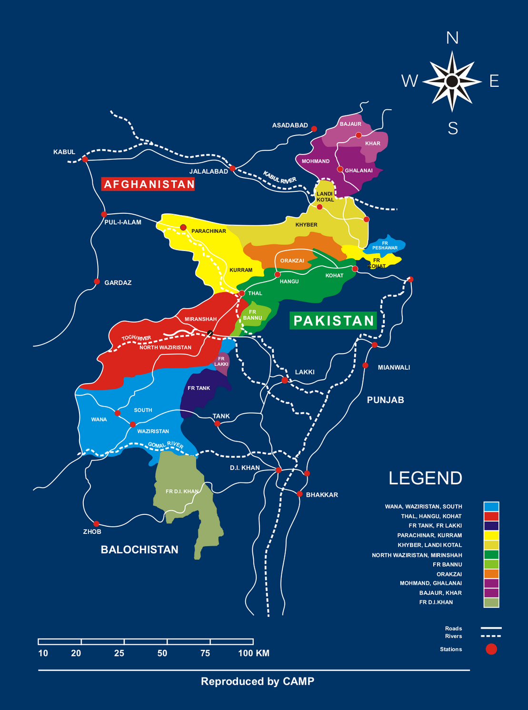
The months of September and October saw an unprecedented number of drone strikes inside of Pakistan’s Federally Administered Tribal areas (FATA). The FATA is where the Afghan resistance retreated to during the jihad against the Soviet Union and is where the Afghan Taliban and al-Qaeda retreated to following the 2001 U.S. led invasion following 9/11. The purpose of this mapping exercise is to graphically display for people who may not be familiar with the FATA the area involved and as close as possible the actually cities in which the drone strikes occurred. In hopes to bring a better understanding of against whom and where the drone strikes are occurring.

The Taliban: Balochistan a settled Pakistani province that is home to the reconstituted Taliban that is associated with Mullah Omar (Commander of the Faithful) and the former rulers of Afghanistan. Following the U.S. invasion of Afghanistan the Taliban re-established their command and control in Quetta Pakistan.
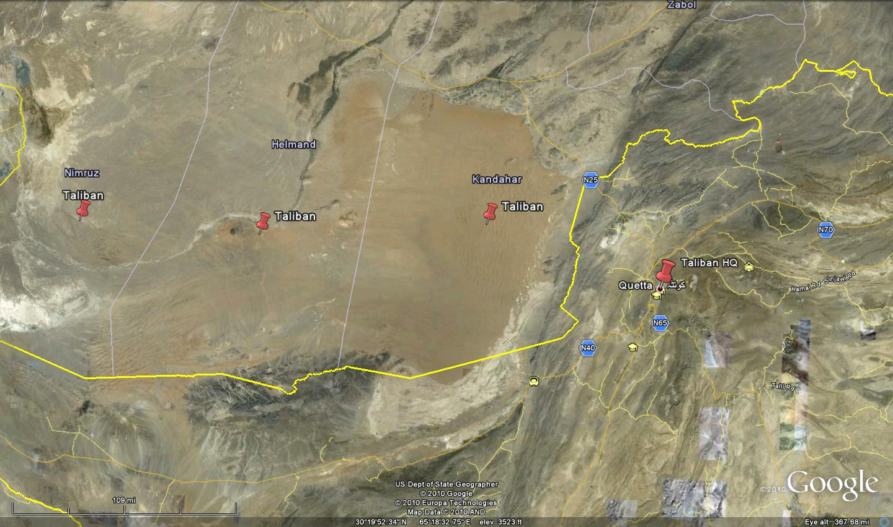
As noted Balochistan especially Quetta is home of the Taliban and reportedly the command shura (council) of the group. The Taliban is strongest in Afghanistan in Nimruz, Helmand, and Kandahar provinces. Kandahar is the spiritual heartland of the Taliban and where the group originated.

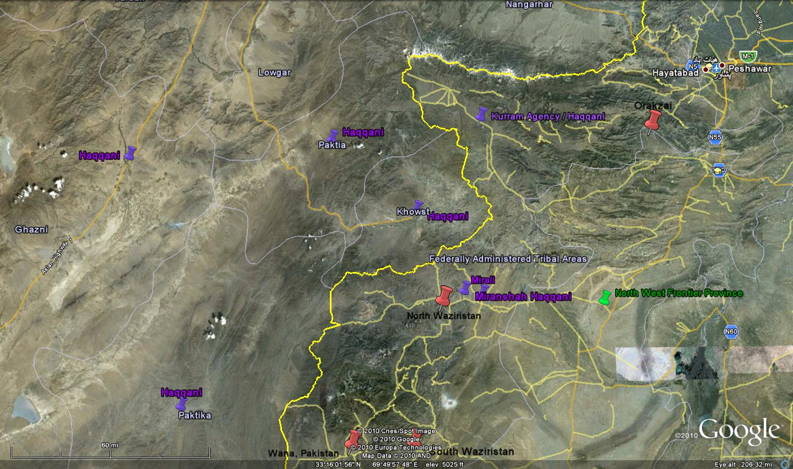
The Haqqani group headed by Jalaluddin and his son Sirajuddin Haqqani are allied with the Taliban and are supporters of al-Qaeda. Jalauddin fought the Soviets during their invasion of Afghanistan and reportedly sits on al-Qaeda shura majlis (this is the board of directors). Siraj Haqqani has taken up where his father left off now fighting the Afghan government and the U.S. and its allies in Afghanistan. This group is responsible for attacks on President Karzi and numerous suicide attacks inside Kabul. Siraj is a key target for the U.S. The Haqqani home is in North Waziristan around the towns of Miranshah and Datta Khel. The Haqqanis also have a presence in the Afghan provinces of Patika, Khowst, Paktia, and Ghazni.
In addition to the drone strike the U.S. launched three helicopter attacks against Haqqani targets starting on 9/25-9/27 killing at least 50 fighters as they retreated from Afghanistan. This caused Pakistan to cut off the land supply routes for several days until the United States apologized. These types of hot pursuit raids are supposedly allowed but Pakistan while tolerating the drone strikes is very adamant against airspace violations by manned aircraft.

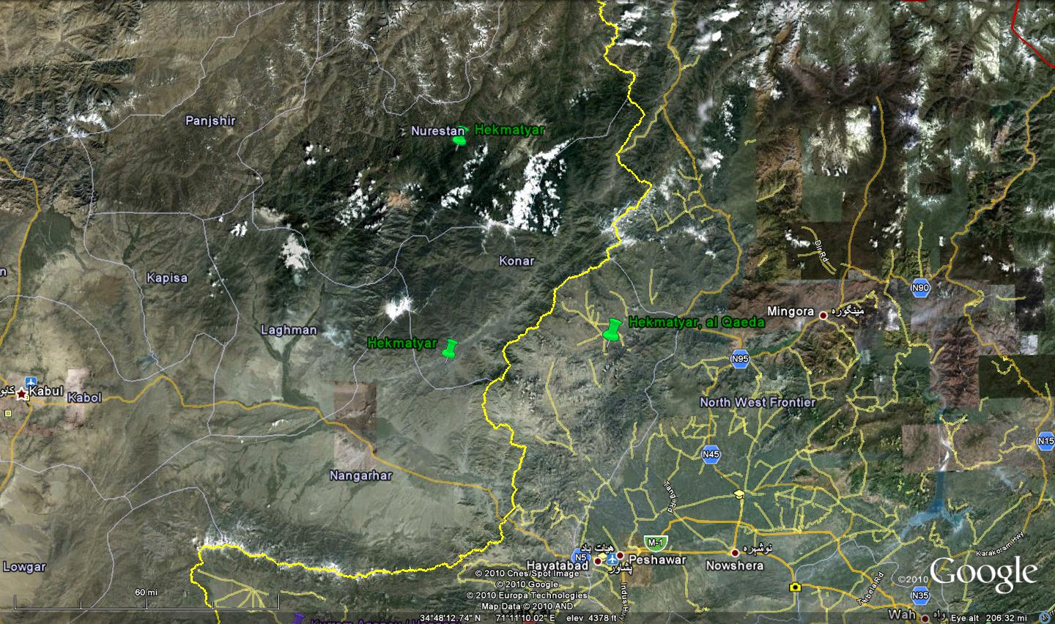
This leads to the areas controlled by Gulbuddin Hekmatyar another hold over from the anti-Soviet jihad. He was forced to flee Afghanistan when the Taliban took over but has since made his return on the side of the Taliban. Hekmatyar’s Hezb –i- Islami operates in the area of the Korengal valley area which saw the withdrawal of U.S. forces earlier in 2010.

The months of September and October saw an unprecedented number of Predator/Reaper drone strikes in the FATA. As we will see these strikes were centered in North Waziristan. In October it was announced that the strikes were related to a Mumbai, India type of attack being planned for Europe in North Waziristan.
This is a map of the drone front:
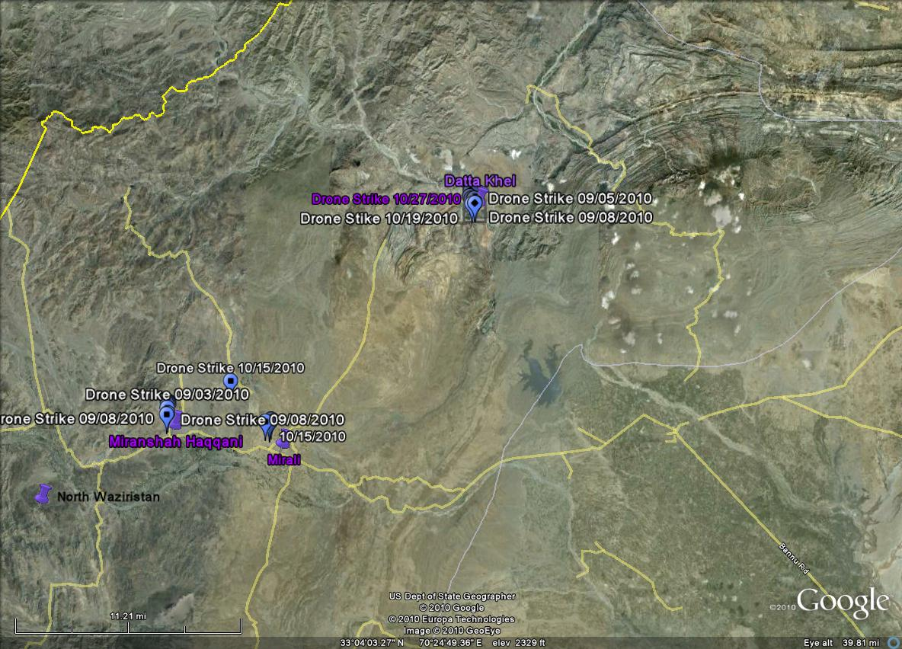
Miranshah is about 30 miles as the crow flies from Datta Khel as we will see these are the two most productive target areas.
The blue markers with a square are attacks were it is claimed only low level fighters were killed. The diamonds represent foreigners while the star denotes a commander or other high value target. The strike markers are as close to the area they occurred as possible as Google Earth does not have a large database of the minor towns in the FATA. Targets are classified as the Taliban unless the groups named is mentioned specifically.

Miranshah
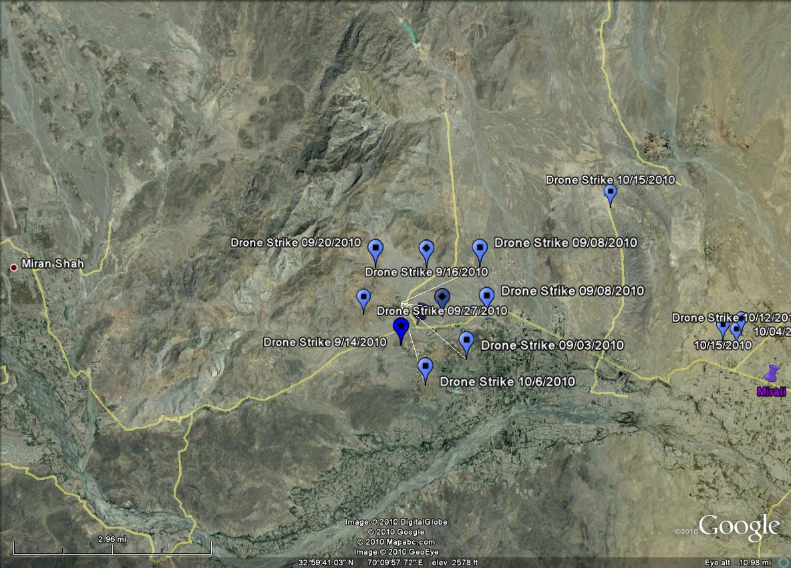
There were eight attacks in and around Miranshah with a total of 43 KIA. The only high value target of note killed was Saifull the first cousin to Sirah Haqqani. A point to keep in mind is that most of the KIAs are low level members. A point to keep in mind about knocking off low level fighters is that when Rudy Giuliani took over as Mayor of New York City he directed his police department to go after all the criminals not just the heads of crime families and drug lords. This strategy led to a decrease in crime over all.
Drone Strike Details
Date of Attack | City Attacked | Province | KIA | Group Targeted | Notes
09/03/2010 | Miranshah | N. Waziristan | 6 | Haqqani
09/08/2010 | Miranshah | N. Waziristan | 6 | Haqqani
09/14/2010 | Miranshah | N. Waziristan | 4 | Haqqani | Saifull first cousin of Siraj Haqqani killed
09/16/2010 | Miranshah | N. Waziristan | 14 | Foreigners and Punjabi Taliban | 10 Missiles fired
09/20/2010 | Miranshah / Mir Ali | N. Waziristan | 4 | Haqqani | 4 Missiles fired
09/27/2010 | Miranshah / Khushali Toorikhel | N. Waziristan | 4 | Haqqani
10/06/2010 | Miranshah | N. Waziristan | 5 | Haqqani | Qari Hussain Mehsud
Qari Meshud a known suicide bomber trainer was supposedly killed. His death has been announced before. It was reported this time on NDTV’s website http://www.ndtv.com/article/world/taliban-s-no-2-. killed-in-us-drone-attack-in-pakistan-60120. There has been no announcement by the Taliban confirming his death.
Mira Ali: A significant attack was made against what could have been the planning or operational cell that was going to attack in Europe. 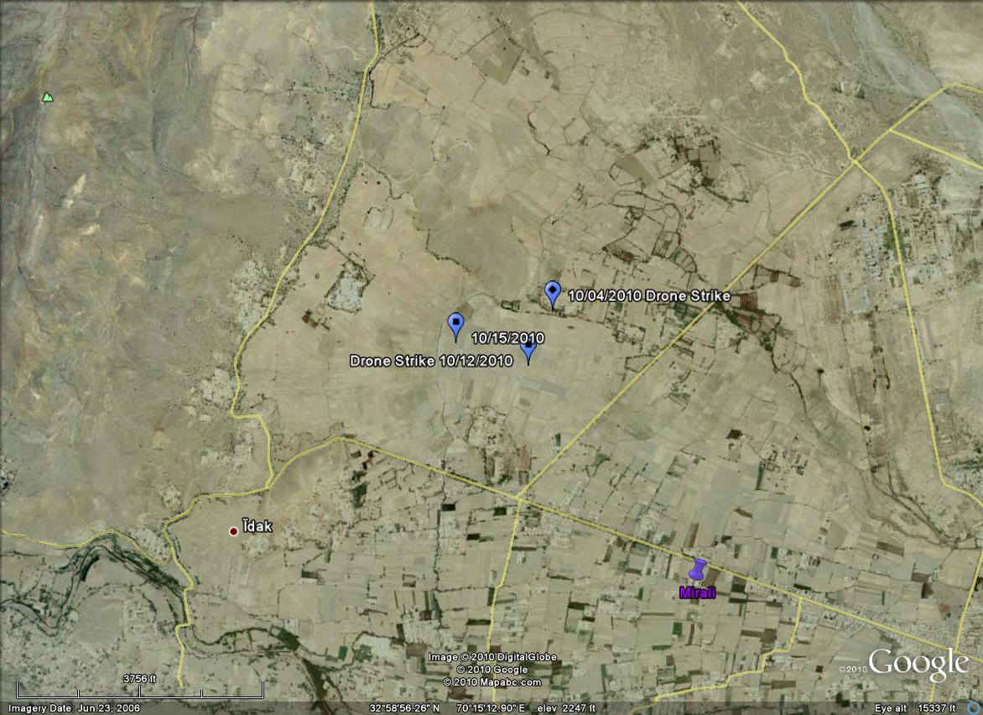
Date of Attack | City Attacked | Province | KIA | Group Attacked | Notes
10/04/2010 | Mir Ali | N. Waziristan | 10 | 8 Germans / Al Qaeda | http://www.atimes.com/atimes/South_Asia/LJ09Df03.html
10/12/20010 | Mir Ali | N. Waziristan | 7 | Taliban
10/15/2010 | Mir Ali | N. Waziristan | 4 | Taliban

Mira Ali is important for the eight German nationals that were killed in one attack. The Asian Times article is well worth the read because the author is a known jihadist sympathizer. The article profiles an up and coming Pakistani al-Qaeda member who specialized in intelligence collection. It is believed he was killed with the Germans in Mir Ali on 10/4/201. This is significant because eight Germans located with an al-Qaeda member that specializes in intelligence collection could be the best proof of an attack being planned to occur in Europe.

Datta Khel another area controlled by the Haqqanis and al-Qaeda received considerable attention in September and October with a total of 18 attacks this area saw more drone strikes than all other areas combined.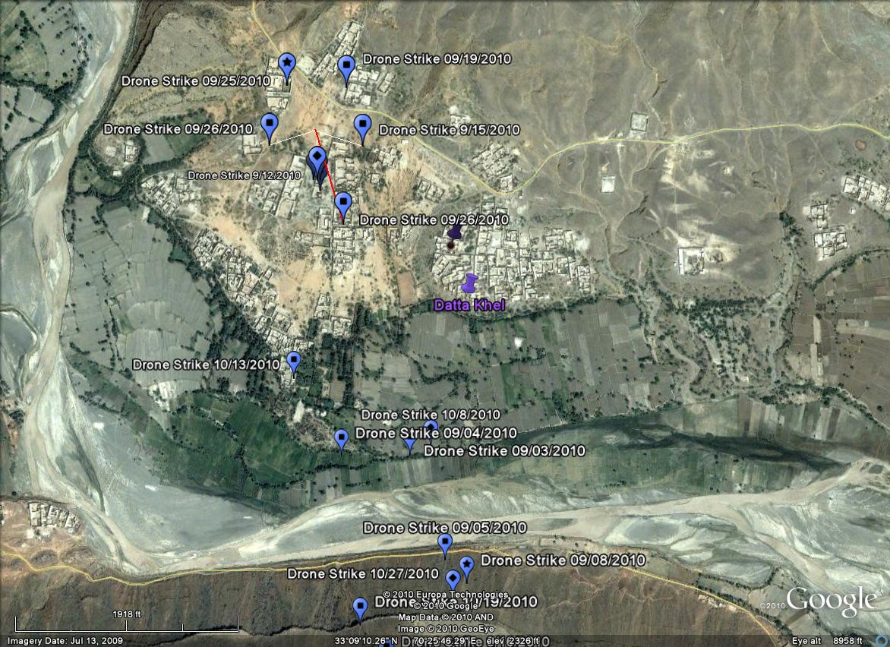
Drone Strike Details
Date of Attack | City Attacked | Province | KIA | Group Attacked | Notes
09/03/2010 | Datta Khel | N. Waziristan | 9 | Foreigners | Taliban commander, Inayatullah, killed in the attack.
09/04/2010 | Datta Khel / Mizar | N. Waziristan | 8 | At least 3 Foreign fighters
09/08/2010 | Datta Khel | N. Waziristan | 8 | 5 Taliban and 3 foreign fighters | Uzbek Commander Qureshi killed
09/12/2010 | Datta Khel | N. Waziristan | 6 | 4 Taliban and 2 foreign fighters
09/15/2010 | Datta Khel | N. Waziristan | 3 | Taliban
09/16/2010 | Datta Khel | N. Waziristan | 4 | Haqqani

09/19/2010 | Datta Khel | N. Waziristan | 5 | Taliban
09/25/2010 | Datta Khel | N. Waziristan | 4 | Taliban | HVT Sheik Fateh al Masri
09/26/2010 | Datta Khel | N. Waziristan | 3 | Taliban | 4 missiles fired
10/02/2010 | Datta Khel | N. Waziristan | 15 | Haqqani/Foreigners
10/2/2010 | Datta Khel | N. Waziristan | 4 | Haqqani/foreigners
10/06/2010 | Datta Khel | N. Waziristan | 3 | Taliban
10/08/2010 | Datta Khel | N. Waziristan | 5 | Taliban
10/13/2010 | Datta Khel | N. Waziristan | 11 | 7 Taliban / 4 foreigners | The foreigners were members of the IMU*

10/19/2010 | Datta Khel | N. Waziristan | 6 |  | IMU members among the KIA
10/27/2010 | Datta Khel | N. Waziristan | 4 | Arab Haqqani members
*(IMU) Islamic Movement of Uzbekistan
Of note: Bekkay Harrach a German citizen was killed as well as Sheikh Fateh al Masri who was the Qaedat al Jihad fi Khorasan (the leader of the al Qaeda jihad in Afghanistan). The only information is they were killed in the Datta Khel area during the time frame of the study.

Datta Khel is a known hub for al-Qaeda in the FATA and the nearly daily attacks were stated to have been to thwart an attack in Europe. There maybe another reason for this focus. The Haqqanis are one of if not the most dangerous groups fighting against the Afghan government and NATO this maybe a focused attempt to degrade them in their home territory to try to get them to the negotiating table. The Haqqanis launched several attacks against U.S. bases in Afghanistan during the time period of this study and got the worst of it on every occasion. The group even failed to overrun a small Afghan outpost right on the border due to U.S. firepower. During the time of this study the U.S. launched two hot pursuit attacks inside of the FATA killing over 50 Haqqani fighters. These attacks were strongly condemned by Pakistan who cut off NATO supply routes for several days. The Haqqanis are regarded as “good” Taliban by the Pakistani Inter Service Intelligence (ISI). Overtly hitting one of the ISI’s favored groups is what may have prompted the stoppage of NATO supplies more than the violation of Pakistani airspace.

Notes:
Fahd Mohammed Ahmed al-Quso, wanted by the FBI wanted al-Quso for his role in the bombing of the USS Cole in 2000. According to reports, a Briton going as al-Quso was killed in the same drone strike that killed Abdul Jabbar. Al-Quso was supposedly the head of an al-Qaeda splinter cell that intended to attack targets across Europe. Later in September an ISI official denied anyone by the name of al-Quso or of British origin was killed.
According to a Turkish jihadist website on Thursday, a terrorist from Germany Abu Askar al-Almani (Shahabb Dashti) was killed along with other foreigners the first week of October in a drone strike. The t Abu Askar al-Almani, an alias for Shahab Dashti, is an Iranian-German who left Hamburg in the spring of 2009 to join the Islamic Movement of Uzbekistan (IMU)
Hellfire missiles as of the 2003 contract cost $34,946 per unit. Predator drones are purchased in units of four with a ground control station and Predator Primary Satellite link for $20 million per unit. Reapers drones are also purchased in units of four with associated sensors at a cost of $53 million per unit. There is no accurate count of the number of Hellfire missiles fired into the FATA to accurately figure the total cost but the reporting confirms 38 launches at a cost of $1.3 million. The Predator/Reapers series of drones has a Class A incident rates ($1 million in damage or Death) of approximately 10.2 per 1,000 flight hours. Even at these costs it is much cheaper to prosecute a campaign remotely than using piloted aircraft or overt troops on the ground in the FATA which the Pakistanis would not allow.

Gul, Imtiaz, The Most Dangerous Place; Pakistan’s Lawless Frontier, 2009, Viking, New York
S.H. Khan, “US drone kills five in NW Pakistan: officials,” Yahoo News, September 6, 2010. Available at http://news.yahoo.com/s/afp/20100906/wl_sthasia_afp/pakistanunrestusmissile.
6 killed in Pakistan drone attack, CNN, September 9, 2010 Available at http://edition.cnn.com/2010/WORLD/asiapcf/09/09/pakistan.us.drone/#fbid=StqwKXSld2c&wom=false.
“Haqqani cousin killed in Tuesday’s drone strike,” Dawn, September 15, 2010. Available at http://www.dawn.com/wps/wcm/connect/dawn-content-library/dawn/news/pakistan/03-haqqani-cousin-killed-in-tuesdays-drone-strike-ss-05.
“Twenty-one militants killed in two attacks,” Dawn, September 16, 2010. Available at http://www.dawn.com/wps/wcm/connect/dawn-content-library/dawn/the-newspaper/front-page/21-militants-killed-in-two-attacks-690.
ÒÔUS drone strike kills four militants in PakistanÕ,Ó AFP, September 20, 2010. Available at http://news.yahoo.com/s/afp/20100920/wl_sthasia_afp/pakistanunrestusmissile.
“US drone strike kills four militants in Miramshah,” Dawn, September 27, 2010. Available at http://www.dawn.com/wps/wcm/connect/dawn-content-library/dawn/news/pakistan/03-us-drone-strike-kills-two-militants-in-miramshah-ss-03
http://www.dawn.com/wps/wcm/connect/dawn-content-library/dawn/news/pakistan/04-no-justification-for-drone-strikes-fo-qs-07.
US drone attacks kill four in North Waziristan,” Dawn, October 15, 2010. Available at http://www.dawn.com/wps/wcm/connect/dawn-content-library/dawn/news/pakistan/07-us-drone-attacks-kill-four-in-north-waziristan-ha-01.
Federick Pleitgen, "Suspected drone strike kills eight in Pakistan," CNN, October 10, 2010. Available at http://edition.cnn.com/2010/WORLD/asiapcf/10/10/pakistan.drone.attack/.
Missile Strike Kills 9 in NWA, September,3rd 2010, http://www.samaa.tv/News25025-Missile_strikes_kill_9_militants_in_NWA_.aspx
“US drone strike kills eight militants in Pakistan: officials,” Yahoo News, September 4, 2010. Available at http://news.yahoo.com/s/afp/20100904/wl_sthasia_afp/pakistanunrestusmissile
Pakistani: Uzbek Warlords Killed by Drones, September 9th, 2010, http://www.adnkronos.com/AKI/English/Security/?id=3.1.937515202
Hasbanullah Khan, “US drone strike kills 'six militants' in Pakistan,” AFP¸ September 12, 2010. Available at http://news.yahoo.com/s/afp/20100912/wl_asia_afp/pakistanunrestusmissile.
“Twenty-one militants killed in two attacks,” Dawn, September 16, 2010. Available at http://www.dawn.com/wps/wcm/connect/dawn-content-library/dawn/the-newspaper/front-page/21-militants-killed-in-two-attacks-690.
Rasool Dawar, ÒUS missile strike kills 5 militants in Pakistan,Ó AP, September 19, 2010. Available at http://news.yahoo.com/s/ap/20100919/ap_on_re_as/as_pakistan. Hasbanullah Khan, ÒUS drone attack kills four militants in Pakistan,Ó AFP, September 19, 2010. Available at
Dawar, Nasar, Drone Attacks Kill 18 Suspected Militants in Pakistan’s Tribal Region, http://edition.cnn.com/2010/WORLD/asiapcf/09/08/pakistan.drone.attack/index.html?eref=edition_asia&utm_source=feedburner&utm_medium=feed&utm_campaign=Feed%3A+rss%2Fedition_asia+%28RSS%3A+Asia%29#fbid=dm8LfFElkvn&wom=false
Lister, Tim, Top Al Qaeda Commander Killed in Drone Strike, September 28, 2010, http://edition.cnn.com/2010/WORLD/asiapcf/09/28/pakistan.militant.killed/index.html?hpt=T2
Rasool Dawar, “Officials: Alleged US missiles kill 4 in Pakistan,” Associated Press, September 25, 2010. Available at http://news.yahoo.com/s/ap/20100925/ap_on_re_as/as_pakistan.
“US drone strikes kill 15 in North Waziristan,” Dawn, October 3, 2010. Available at http://www.dawn.com/wps/wcm/connect/dawn-content-library/dawn/news/pakistan/06-us-drone-strikes-kill-15-in-north-waziristan-rs-01.
“US drone strikes kill 15 in North Waziristan,” Dawn, October 3, 2010. Available at http://www.dawn.com/wps/wcm/connect/dawn-content-library/dawn/news/pakistan/06-us-drone-strikes-kill-15-in-north-waziristan-rs-01.
“US drone kills five in northwest Pakistan: officials,” AFP, October 9, 2010. Available at http://www.google.com/hostednews/afp/article/ALeqM5jydV9V7DnFE7EPP5BRKsb_3Tvrhw?docId=CNG.5eafcba4bf53b470f39c1ecb5aaf1e29.bc1.
US drone strike in Pakistan 'kills eight militants',” BBC World News South Asia, October 13, 2010. Available at http://www.bbc.co.uk/news/world-south-asia-11538743.
'Six militants die' in Pakistan drone attack,” BBC South Asia, October 19, 2010. Available at http://www.bbc.co.uk/news/world-south-asia-11571471.
Hasbanullah Khan, “US drone strikes kill up to six in Pakistan: officials,” AFP, October 27, 2010. Available at http://news.yahoo.com/s/afp/20101027/wl_sthasia_afp/pakistanunrest.
Duncan Gardham, Alex Spillius, Rob Crilly, "Terrorist on FBI most wanted list 'killed by drone'," Telegraph, October 6, 2010. Available at http://www.telegraph.co.uk/news/worldnews/asia/pakistan/8047215/Terrorist-on-FBI-most-wanted-list-killed-by-drone.html. “Briton killed by drone in Pak ‘was to be terror chief’,” Dawn, October 6, 2010. Available at http://www.dawn.com/wps/wcm/connect/dawn-content-library/dawn/news/world/12-briton+killed+by+drone+in+pakistan+was+to+be+terror+chief--bi-03?utm_source=feedburner&utm_medium=feed&utm_campaign=Feed:+dawn/news/world+(DAWN.COM+-+World+News)
Paul Cruickshank, “Jihadist website: One of Hamburg terror group killed in drone strike,” CNN, October 7, 2010. Available at http://edition.cnn.com/2010/WORLD/asiapcf/10/07/pakistan.jihadist.death/index.html?eref=edition_asia&utm_source=feedburner&utm_medium=feed&utm_campaign=Feed:+rss/edition_asia+(RSS:+Asia).
Global Security.org, AGM-114 Hellfire Chronology, No Date, http://www.globalsecurity.org/military/systems/munitions/agm-114-chron.htm
U.S. Air Force, MQ-1B Predator, 07/20/2010, http://www.af.mil/information/factsheets/factsheet.asp?fsID=122
U.S. Air Force MQ-9 Reapers, 08/18/2010, http://www.af.mil/information/factsheets/factsheet.asp?fsID=6405
Christian, Drone Losses Debate, February, 2, 2010, http://defensetech.org/2010/02/09/drone-losses-debate/

